Shared Power Assignment report

Group Members and student ID:
- Suman Naz 1815369
- Alina Coanda 1812273
- Kehua Wang 1814078
- Duke Ludera 1800887
- Courage Mabani 1718805
- Azib Anees 1806562
- Amidu O Alejolowo 1614183

Introduction:
We as a group of 7 members had to create a software called “Shared Power” which would help tradesmen to share their tools. The users interested in hiring the tool can book tools for up to 3 days and they can search for the availability of the tools for up to 6 weeks in advance. They would also have the tools available to them per day and per half day rate for each unit. There would be an option for the tools to be either collected or delivered.
On the other hands, if a tool is returned late then there would be a fine of double the day rate for every day it is late. We also realized that our system had to be able to produce invoices for all the users on monthly basis. It was essential for the invoice to include the hire charges, delivery cost and late fee (if applicable). It was also necessary for the invoice to add a £5 insurance bill in all monthly bills.
The system allows the owners to take pictures/notes of the tools when they are uploaded on the system. There would be an investigation carried out by the insurance company if there is a serious issue of damage. The insurance company would have to determine who is at fault and who would need to pay for the repair of the tool(s).
After we finalized what we had to do, we decided to split the work between us and start working on the project.

UML Diagrams:
We started by creating the Sea Level Diagram and identifying three actors as Tradesman, Hirer and Administrator.
Sea Level Diagram (See Appendix 1)
- The Tradesman will Login, Add the tools, Edit his profile, Verify the tool condition once returned from the Hirer and Give review.
- The Hirer will Login, Select the tools, Edit his profile, Return the tool and Give review.
- The Administrator will Login, Generate monthly invoices and Open complaint message from Tradesman.
Going further by creating the Fish Level we went into more depth of what each Use-Case does.
Add Tools Diagram (See Appendix 2):
The Tradesman can add the tools for rent where he can add Special Note, Tool Specification, Address, Price and Upload picture. The tool specification will include the general properties of tools but special notes and picture from tradesman will be used by hirer to verify things like damages, duration of usage, tool usage guidance. The pickup address will also be used by Hirer to know the location of Tradesman, so he can pick up the tool from that address. Tradesman will also add the price which is a generalization because he can add the Half-day or Full-day price. Finally, the tradesman can rent the tool
Verify Tool Condition Diagram (See Appendix 3):
The Tradesman will Open the Tool Picture and if there is any problem with the tool or if the tool is returned late, he will Report that to Administrator.

Select Tool Diagram (See Appendix 4):
The hirer will select the quantity of the number of tools he wants to select. Photos and Notes are from tradesman for Hirer to have a look at the tool. Distribution method has a generalization for pickup and delivery. Which gives an option to Hirer that if he wants the tool to be delivered, he will have to give his address and if he wants to pick up the tool, he will use the address given by the tradesman, With the agreed time and date between both users.
Return Tool Diagram (See Appendix 5):
The Hirer will Upload a Picture and Notes of the tool condition after he has used it.
Edit Profile Diagram (See Appendix 6):
This diagram involves both Tradesman and Hirer where they can Edit their profile, by changing information such as First Name, Last Name, Age, Address, Phone number, Email Address Username and password.
Login Diagram (See Appendix 7):
Both Tradesman and Hirer can Login the System as an Existing user or by Creating a new account.
Open Complaint from Tradesman Diagram (See Appendix 8):
The Administrator will Open the complaint message which he receives from the Tradesman and Contact the insurance company if any damage is done to the tool. The insurance company will the investigate and decide who is going to pay for repair.

Generate Monthly Invoices Diagram (See Appendix 9):
The Administrator will generate the monthly invoice by calculating the Hire charges, the Delivery cost (if applicable), add a Late fee if the tool was not return on time (the Late fee is double the per day price for each day it is late) and add an Insurance fee of 5£.
We kept the clam level very simple where the user just adds the information for creating account or logging in.
Existing user diagram (See Appendix 10):
All the actors from our system, the Tradesman, the Hirer and the Administrator adds a Username and a Password for accessing the system.
New User Diagram (See Appendix 11):
The Tradesman and the Hirer can create a new user, by adding the name, last name, age, address, phone number, email address username and password.
The activity diagram follows the sequence that place in these use cases.
Activity Diagram for Tradesman (See Appendix 28):
The Tradesman starts by Login in the system which is followed by a New User or an Existing User. If the Tradesman is an existing user, he will write his user name and password and login in. If the Tradesman is a new user, he will have to add all the details and then register.
Once entered inside the system the Tradesman has four options to choose from which are Verify Tool Condition, Add Tools, Give Review and Edit Profile. In verify tool condition the tradesman open tool picture the report to administrator and can Logout. For Adding tool he first has to write tool specification, then notes about tool, his pickup address and price either in Full day or in Half Day. When the price is written he can upload picture, rent the tool and Logout. Tradesman can give review and can logout. After editing the profile he can save it and Logout.
Activity Diagram for Hirer (See Appendix 29):
The Hirer starts by Login in the system which is followed by a New User or an Existing User. If the Hirer is an existing user, he will write his user name and password and login in. If the Hirer is a new user, he will have to add all the details and then register.
Once entered inside the system the Tradesman has four options to choose from which are Return Tools, Select Tools, Give Review and Edit Profile. In returning tool the hirer first uploads the picture, then write the notes and can Logout. For selecting the tool hirer first chooses the quantity then chooses the distribution method which is either pickup or delivery. The hirer then choose date which is the purchase date and writes his address. When the order is complete, he can confirm order and Logout. Hirer can give review and can logout. After editing the profile, he can save it and Logout.
Activity Diagram for Administrator (See Appendix 30):
The administrator logins inside the system by entering user name and password and have two options to choose from which are either generate monthly invoice or open complaint message from tradesman. For generating invoice, he calculates the total cost, add the late fee, add the delivery cost and add the insurance. By opening complaint message, he can message to insurance company and update the unavailability of tool and can finally logout.

Assumptions and constraints:
The first assumption we made in this project was that the owners/users were already registered in this software and they did not have to create an account before they could log in. However, this assumption was later proved wrong because after having a meeting with the client we realized that the owners/users were not already registered, and they had to register themselves first in the system and only after that they could log on.
Another assumption we made was that the insurance charge of £5 would be added to all the rentals in the invoice. For example, if an individual rented than 10 items in a month then there would be a charge of £50. However, this assumption was later cleared by the client; they informed us that only a charge of £5 would be added per month regardless of how many items were rented in that month. Therefore, as a result our program had to be adapted accordingly.
Before the development phase we also made more assumptions in the designing, but they changed, and they are as follows;
- The Select Tool Use Case in Sea level was previously named as search for tools
- We had a Use-Case for Hire Tool in Sea Level diagram but that changed and was included in the fish level diagram of Select Tool.
- We had a verify return date and time Use-Case in the return tool fish level diagram but that just changed to upload picture.
- We had bank details Use-Case whenever the user makes the payment, but we assumed that there will be no payment in this system.
- In select tool we had a Use-Case for checking the availability of a tool of 6 week, but we could develop it
- We had a Use-Case for giving the user the return date of returning the tool in three days.
- In administrator section we had a Use-Case for Insurance request where the insurance manager pays for repair and the unavailability of the tool was updated. But that changed as now the administrator will receive the complaint from the tradesman and send a message to the insurance company.

We could not develop these scenarios as they were too complex and required a lot of different functions. Apart from this we faced problem in merging each other python file as we all used our own way.

Development Phase:
In development phase we used global in every function and created the Graphical User Interface with Tkinter package. We imported other packages like OS for allowing us to interface with underlying operating system that python is running on in our case which was Windows. Random package for generating random numbers in invoice. Time-date package for generating current dates in the invoice. File-Dialog package for uploading and printing files on the system. And Message Box package for displaying appropriate messages, like asking questions, showing information to the users. We have referenced the code at the end of each function wherever required.
The development phase is divided into four sections starting with Login Interface. We created three buttons for Tradesman, Hirer and Administrator (Appendix 12). The Hirer and Tradesman needs to Create an account before Login inside the system. They can do this by adding personal information including username and password which gets saved on a file. Once the account is created the Hirer and Tradesman can Login inside the system by clicking the Existing User button. (Appendix 13 and 14). If the user inputs the wrong password and username the python verifies it by comparing it to the file stored and displays error. (Appendix 18)
The administrator on the other hand can simply login inside the system by using the username and password used in Hirer and Tradesman Interface. (Appendix 15).
For each heading on every window we used light blue background color and large font size. The screen size is adjusted according to the size of buttons and labels on the window by the geometry size function (Appendix 16)
The second section is the welcome window for tradesman. He can Add Tools, Edit Profile, Give Reviews, Verify Tool Condition and Finally Logout. (Appendix 13). The Hirer has the same buttons as tradesman except for Select Tools and Return Tools (Appendix 14). We used entry boxes for adding tool price, Text Widgets for tool specification and special notes. The upload picture uses file-dialog to search for file on the desktop and print the path file, which has also been in the hirer section when the hirer returns the tool. File-dialog function has also been used in opening tool picture button which is on verify tool condition window when the tradesman gets his tool back. The rent tool button simply deletes the screen where we used the screen destroys function. (Appendix 17)
In edit profile window we first converted text variable to strings and used them in Labels. The entry box is used for adding information and the insert function is used for the information to be already present. We copied this function Edit Profile and Give Review with different screen names and used it in Hirer section. (Appendix 19)
The logout button uses message box which asks user for confirmation and destroys the screen when pressed yes. This function has also been used in other places like Hirer and Administrator windows. (Appendix 20)
In Hirer section for selecting tools we defined five tools which will open separate windows. For each tool that we defined we copied the same step for other tools. (Appendix 21). When clicked on any tool it will show the picture which we added by importing the PIL package from Tkinter. The function used for picture uses the Canvas method and only supports GIF format (Appendix 22). The tool description uses label, select quantity uses spin boxes and radio buttons for selecting the distribution method. (Appendix 12). For selecting dates, we used Option-Menu which selects year, month and day. (Appendix 23). When the hirer completes this process, he will complete the order by clicking confirm order which will display a message box and delete all he previous windows. (Appendix 25)
The Administrator Generate Invoices and Receives Complaint from the tradesman. (Appendix 15)
The invoice is an interactive window which involves a lot of functions. We used different frames for different sections and adjusted them with buttons, labels and entry boxes.
The invoice number uses the random.randint function and generates a random number every time the button Invoice number is pressed. The date is updated every-time the window is opened. There are five tools where the user can add the quantity and when the total cost button is pressed it multiplies the quantity with the tool price and display in entry boxes. The reset button has each variable defined in it which when pressed removes all the data from the entry-boxes. Once the total cost is calculated it add the insurance and VAT. The delivery button has two buttons and so does the late fee which when clicked deduct or add the number. When all the data is entered, and display invoice is clicked it displays the summary of all the data entered (appendix 26) and saves the invoice in a file. (Appendix 27)
The complaint button on Administrator window has an option of open complaint file. This button uses the open file function which searches for a specific file, read it and prints all the text so it looks like that the administrator has just received a complaint from tradesman.

Software testing:
In this project we did manual testing and the initial requirements are as follows:
- Requirements analysis: We ensured that the application is accessible and usable by people in every operating systems (OS).
- Defect logging: We took notes on faults (bugs) and logging them for debugging
We did functional testing of the whole application, starting with running the application on IDLE checking that all the buttons are workings and responding to clicking and the windows systems is moving accordingly to the next page. We tested the systems on different platform (OS) to check how it behaves and noted if there are any changes with the graphics and text. The where a few bugs noted which where validated by developers in the team.
Test Scenario | Test Case | Pre-Condition | Test Step | Test Data |  | Expected  Result |  | Actual  Result |  | Pass  /Fail
Check  Login as Tradesman  Functionality | Check Respond on entering valid name and password | 1.Application must be installed  2. Register | 1.Launch Application  2.Enter  Name  3.Enter password  4.click Login |  | 1.Name  Azib  2.Password  1234  1.Name  Courage  2.Password  mabani |  | Login must be successful |  | Login  Fail | Fail

- Login fail due to Python imaging library (PIL) module not found.
- Login fail because not verifying the correct username and password for users.
Refereed back to Developers for debugging

Test Scenario | Test Case | Pre-Condition | Test Step | Test Data |  | Expected  Result |  | Actual  Result |  | Pass  /Fail
Check  Login as Tradesman  Functionality | Check Respond on entering valid name and password | Application must be installed.  2.Register | 1.Launch Application  2.Enter  Name  3.Enter password  4.click Login |  | 1.Name  Azib  2.Password  1234  1.Name  Courage  2.Password  mabani |  | Login must be successful |  | Login  Successful | pass

Login as Administrator
Test Scenario | Test Case | Pre-Condition | Test Step | Test Data |  | Expected  Result |  | Actual  Result |  | Pass  /Fail
Check  Login as  Admini  Functionality | Check Respond on entering valid name and password | Application must be installed.  2.Register | 1.Launch Application  2.Enter  Name  3.Enter password  4.click Login |  | 1.Name  Azib  2.Password  1234  1.Name  Courage  2.Password  mabani |  | 1. Login must be successful  2.moves to next window |  | Login  Successful | pass
- After clicking login moves to the next page performance good Pass.
- After clicking button window moved to the required page

Generate monthly invoice
Test Scenario | Test Case | Pre-Condition | Test Step | Test Data |  | Expected  Result |  | Actual  Result |  | Pass  /Fail
Check  Invoice  Functionality | Check Invoice Respond entering valid Data. | Application must be installed.  2.Register | 1.Launch invoice.  2.Data input.  Generate invoice. |  | 1.Invoice input.  2.Data Input. |  | Invoice generated |  | invoice  Successful | pass

Logout test case
Test Scenario | Test Case | Pre-Condition | Test Step | Test Data |  | Expected  Result |  | Actual  Result |  | Pass  /Fail
Logout  Functionality | Checking if logout closes all the window. | Application must be installed.  2.Register | 1.Launch invoice.  2.Data input.  Generate invoice. |  | 1.Invoice input.  2.Data Input. |  | Invoice generated |  | invoice  Successful | pass
- Logout functionality worked well. Going back to home page.

Login as Hirer
Test Scenario | Test Case | Pre-Condition | Test Step | Test Data |  | Expected  Result |  | Actual  Result |  | Pass  /Fail
Check  Login as Hirer  Functionality | Check Respond on entering valid name and password | Application must be installed.  2.Register | 1.Launch Application  2.Enter  Name  3.Enter password  4.click Login |  | 1.Welcome hire window.  2. Search tool.  3.check image and details |  | Show images, price, details. |  | Successful  Showing image, price and details | pass

issues identified and how they were resolved:
We solved the login issue by creating separate verify function for each user because python was saving the account information as whole one user. Where python should have given error and it was not giving us error, we fixed that by making sure that the file on which account data is being saved is the same directory as IDLE file.
When merging invoice, we created problems as we used global and the original file didn’t use that. So, we had to convert variables to txt format and globalize them in each function.
Before merging the invoice file, we also faced problems in giving some buttons specific commands. We couldn’t workout the Late fee button which was supposed to double the rate for each tool instead we manually set daily Late Fee of 660 if all tools were selected. We could not create a code by using global to make our original invoice display to appear the same in the main project, however, this can be solved manually by adding a pound sign and number of items in the invoice folder.
Another issue was in trouble shooting. The main challenge was to combine delivery charges and late fee together. We had to do some additional research on Stack Overflow to create a function to make a delivery charge button which can deduct and add charges from the invoice and can be calculated and displayed in the display window. We resolved this by creating a function called DeliveryCharge. We have not managed to create a code to apply a daily double charge, however, we resolved the problem by creating a prototype function called LateFeeCharge.

appendix:
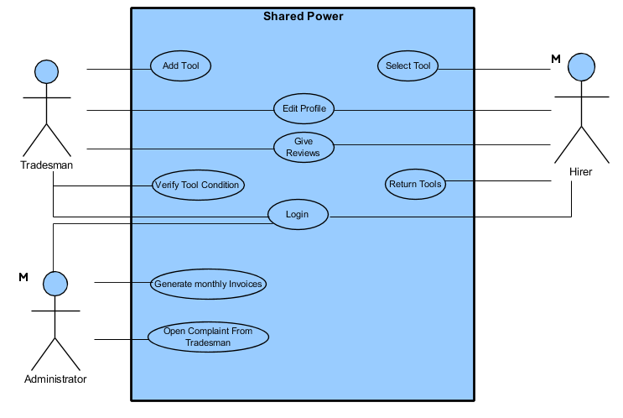
Appendix 1: Sea Level Diagram

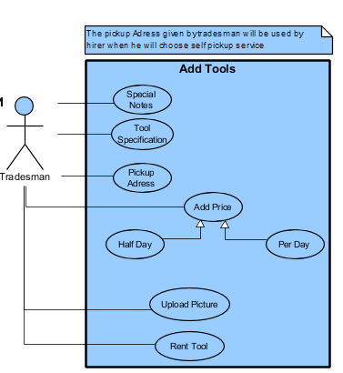
Appendix 2: Fish Level Diagram (Add Tools)

Appendix 3: Fish Level Diagram (Verify Tool Condition)

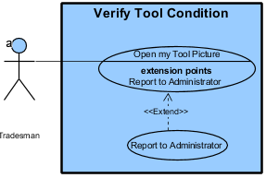

Appendix 4: Fish Level Diagram (Select Tools)
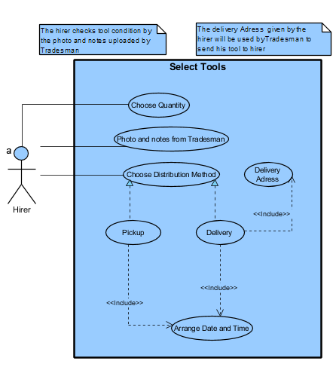

Appendix 5: Fish Level Diagram (Add Tools)
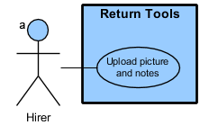

Appendix 6: Fish Level Diagram (Edit Profile)
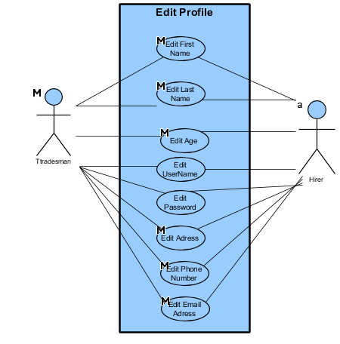

Appendix 7: Fish Level Diagram (Login)
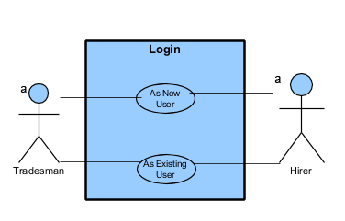

Appendix 8: Fish Level Diagram (Open Complaint from Tradesman)
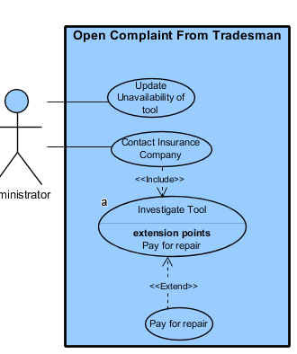

Appendi9: Fish Level Diagram (Generate Monthly Invoice)

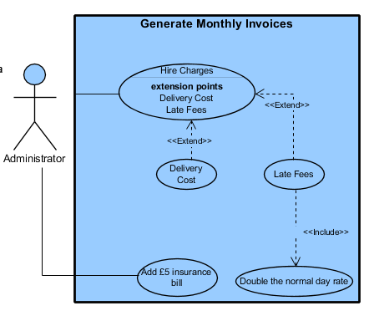

Appendix 10: Clam Level Diagram (Existing User)
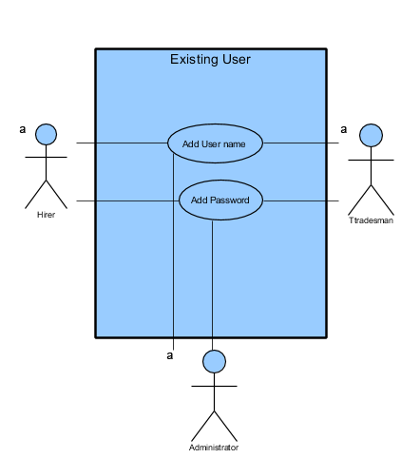

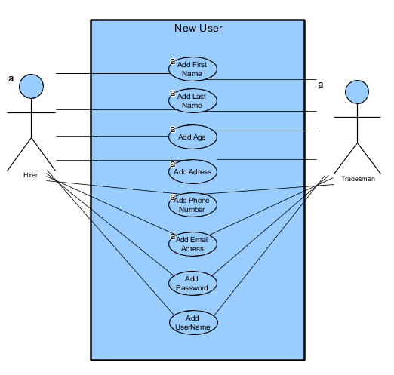
Appendix 11: Clam Level Diagram (New User)

Appendix 12
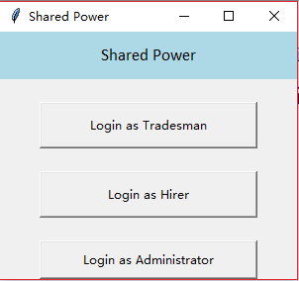

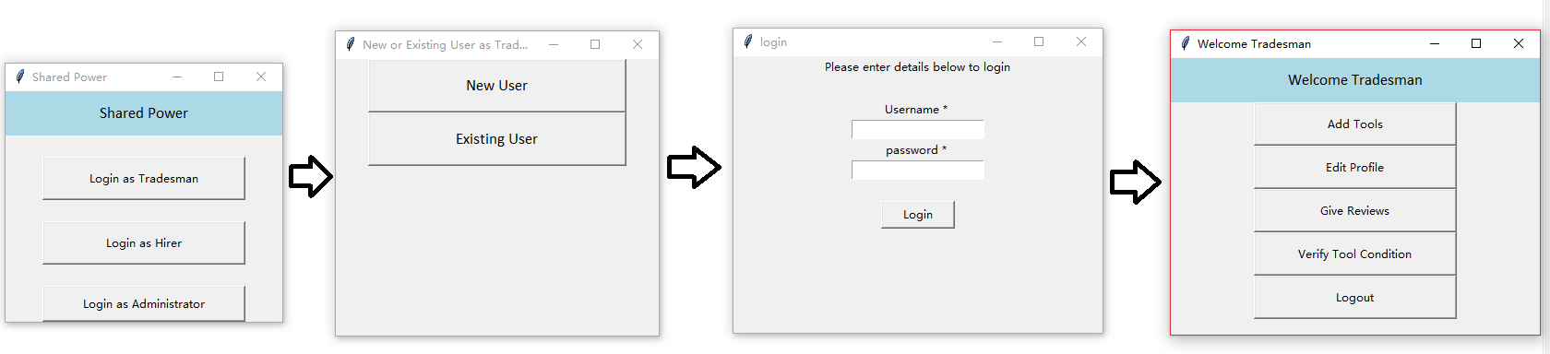
Appendix 13:

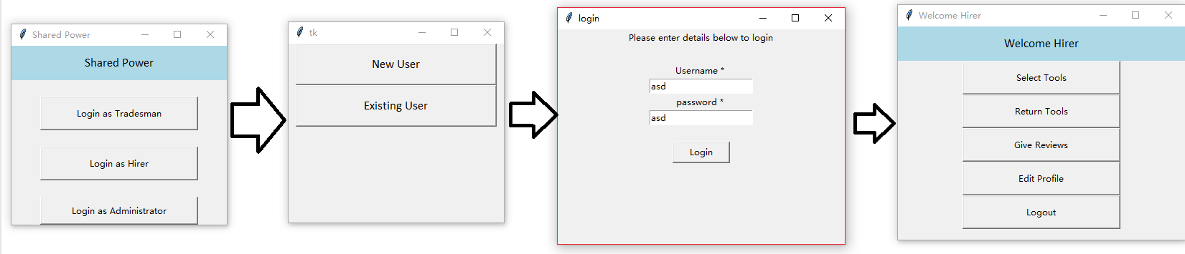
Appendix 14:

Appendix 15
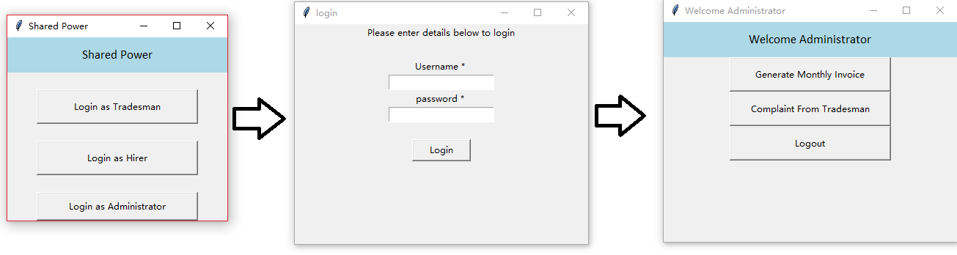

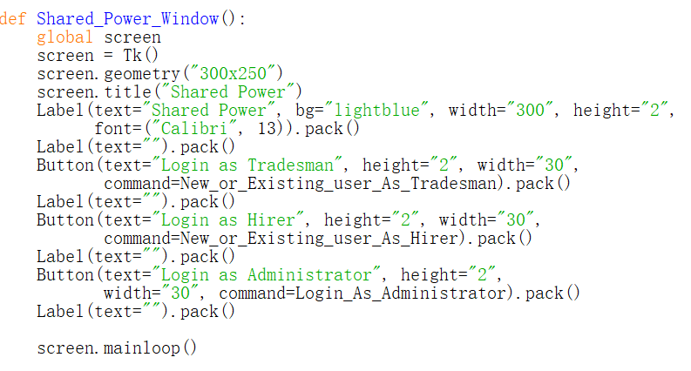
Appendix 16

Appendix 17

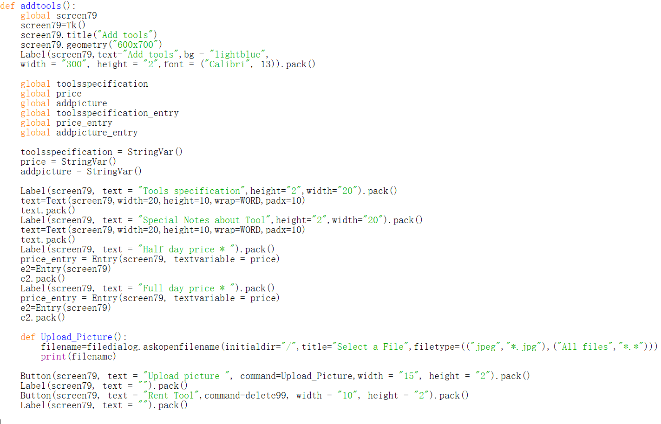

Appendix 18
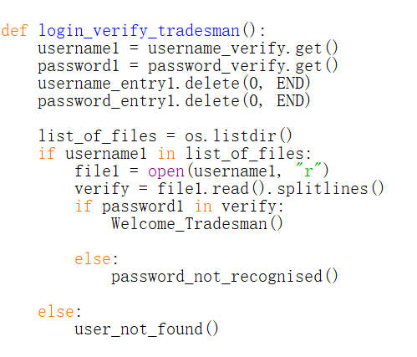

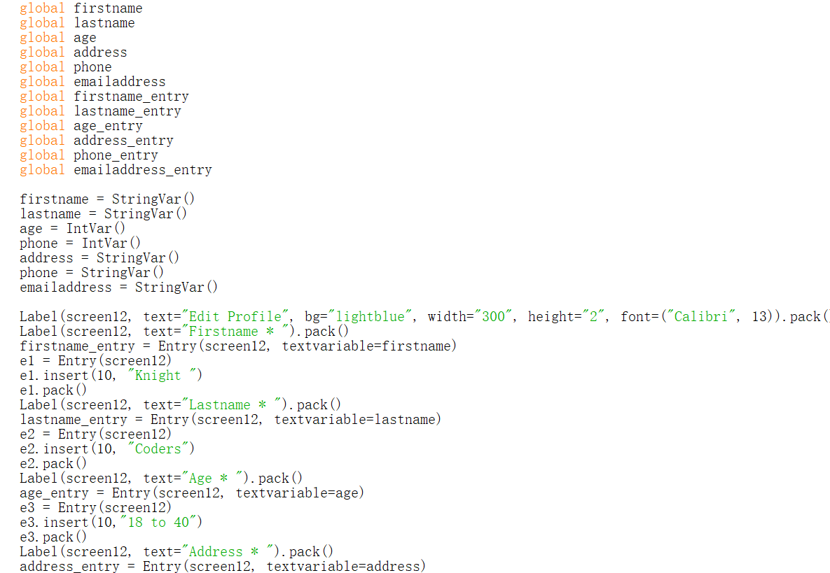
Appendix 19

Appendix 20
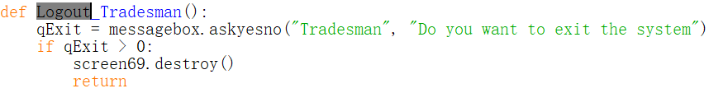

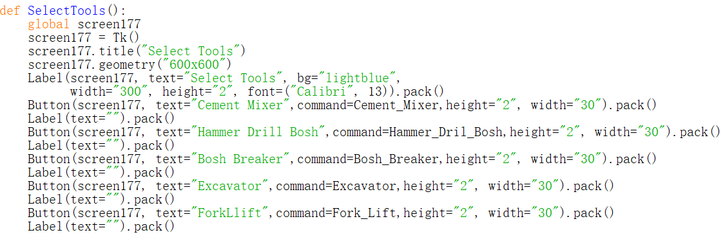
Appendix 21:

Appendix 22:
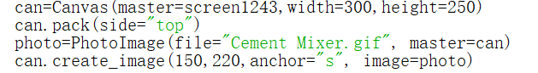

Appendix 23:
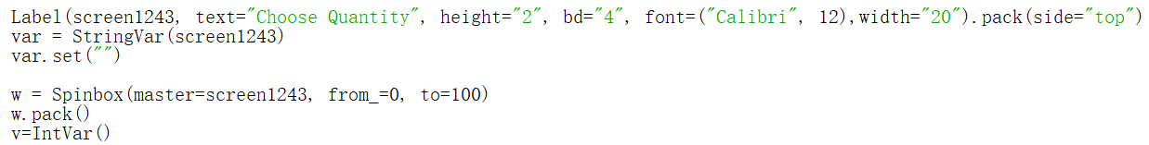

Appendix 24:
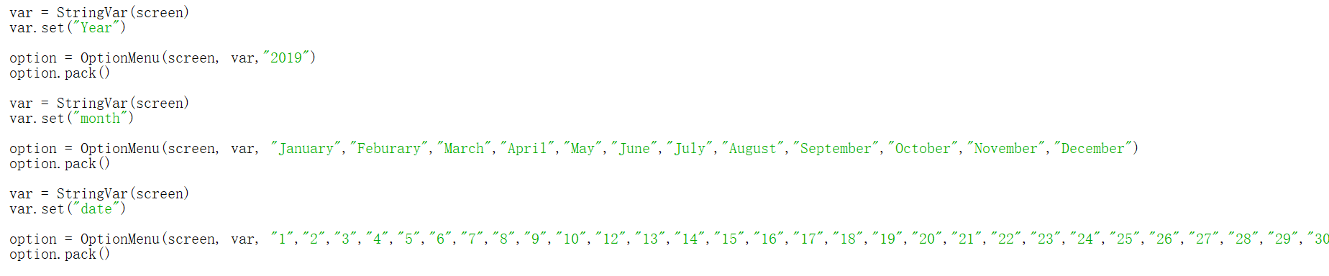

Appendix 25:
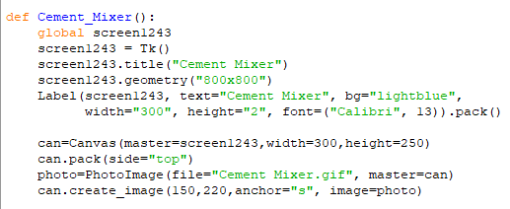

Appendix 26:
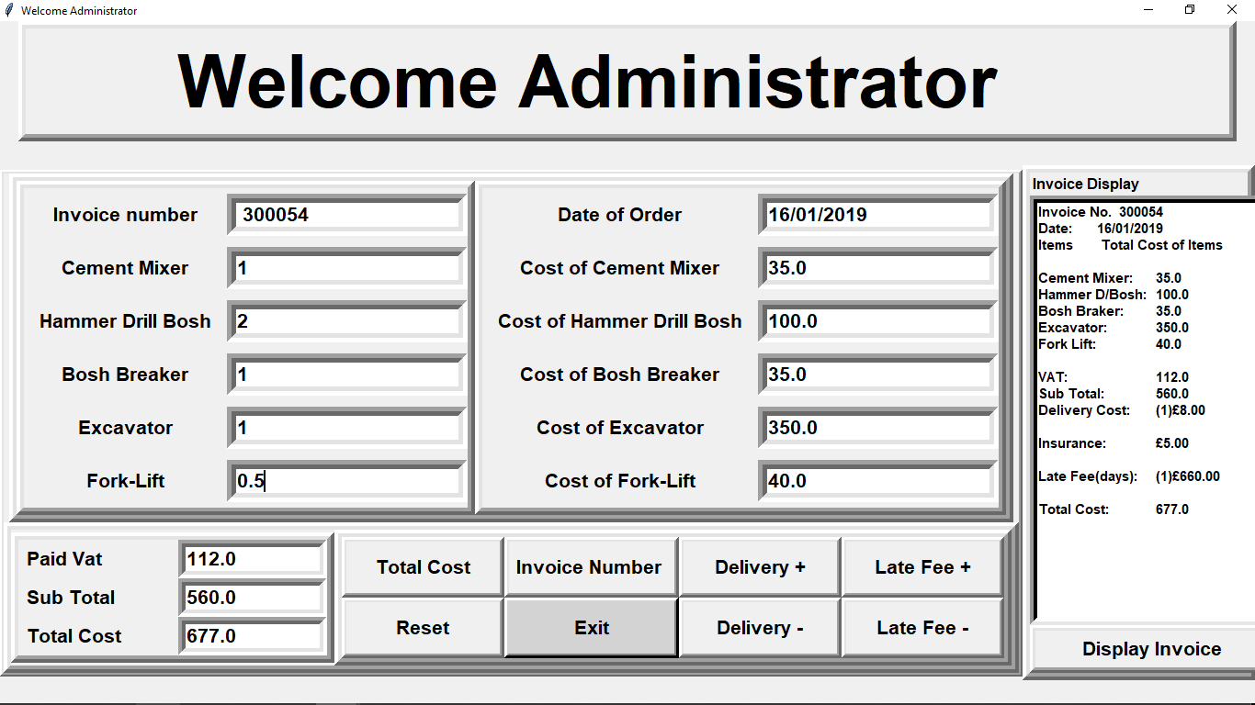

Appendix 27:
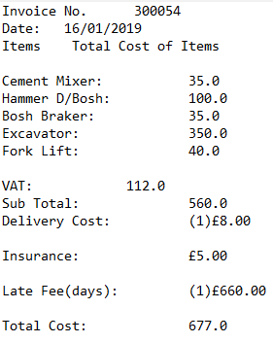

Appendix 28:

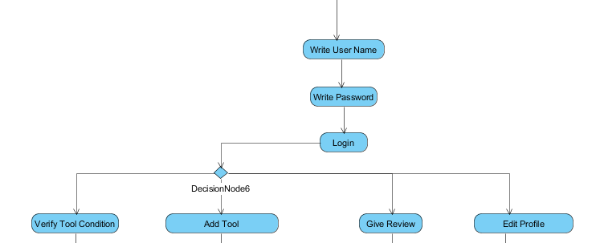
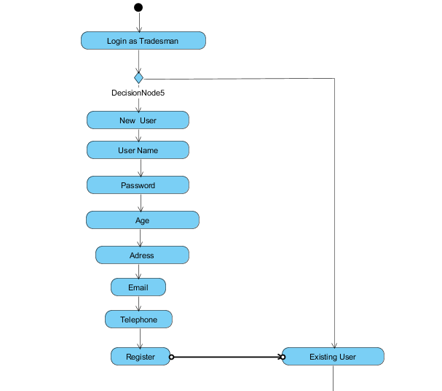

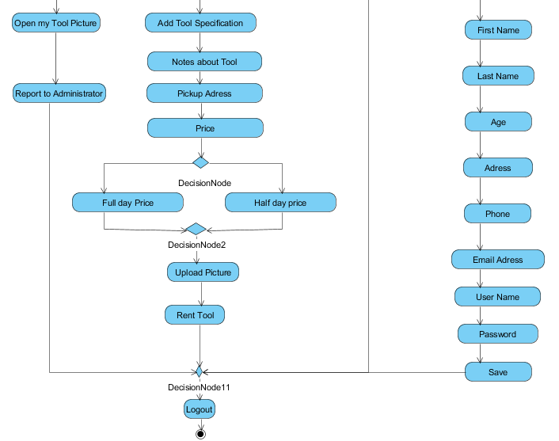

Appendix 29:

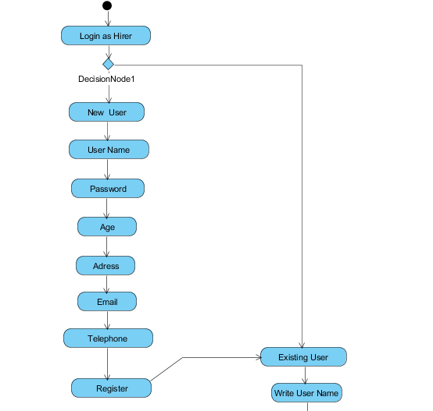

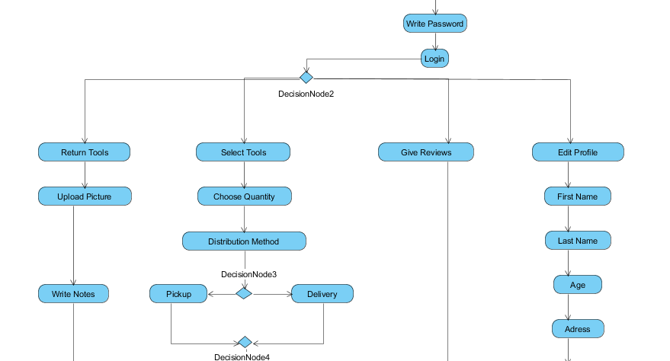

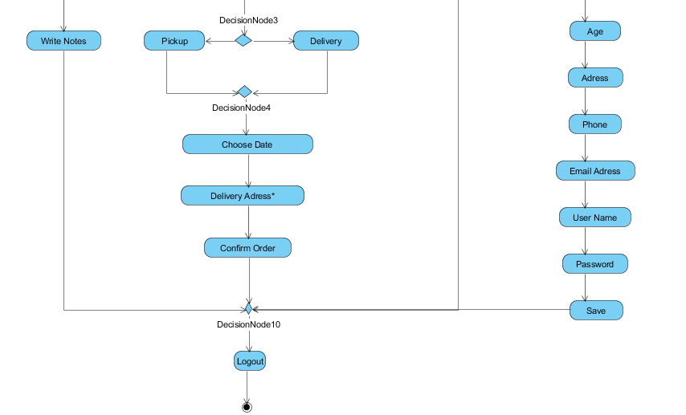

Appendix 30:
